# RISING TEMPERATURES COULD LEAD TO ZOOPLANKTON POPULATION EXTIRPATION UNLESS MET WITH REDUCTIONS IN SIZE AT MATURITY.

Authors: Grant A. Woodard1*, Jan Ohlberger1,2, David G. Kimmel3, Max Lindmark4

1School of Aquatic and Fishery Sciences, University of Washington, Seattle, WA 98195, USA

2 Washington Department of Fish and Wildlife, 1111 Washington St. SE, Olympia, WA 98501, USA

3National Oceanic and Atmospheric Administration, Alaska Fisheries Science Center, 7600

Sand Point Way NE, Seattle, WA 98115

4 Department of Aquatic Resources, Institute of Marine Research, Swedish University of Agricultural

Sciences, Turistgatan 5, SE-453 30 Lysekil, Sweden

*Correspondence: Email: gwoodard@fourpeaksenv.com

## ABSTRACT

Climate change is warming the earth and its oceans, and these trends are expected to continue for the next century. Temperature changes could have major ecosystem impacts starting at lower trophic levels such as zooplankton and cascading up the food web. One such potential change is a shift in zooplankton size structure. Here we seek to assess impacts on zooplankton population demographics in the Bering Sea using a physiologically structured population model consisting of a semi chemostat phytoplankton resource and a zooplankton consumer (*Calanus* spp*.*) divided into a juvenile and adult stage. Our model predicts that warming will lead to increased extinction risk in *Calanus* spp. starting at around 15°C, but that decreases in size at maturity would allow the population to persist at higher temperatures. However, a smaller size at maturity would result in a shift in the size structure of the population. A marked reduction in *Calanus* spp. populations would reduce an important forage base for many higher trophic level species, including fish, birds, and marine mammals. Furthermore, a shift in size structure may impact match-mismatch dynamics between larval and juvenile fish and their prey. Both could have cascading impacts to the rest of the ecosystem including reductions in ecosystem carrying capacity and size at age of commercially important fish species.

## INTRODUCTION

Climate change has warmed the Earth on average 0.062 °C each decade between 1900 and 2019 (Garcia-Soto et al. 2021) and scientists project global warming will exceed 2 °C by the end of the 21st century, unless greenhouse gas emissions are reduced substantially in the coming decades (IPCC 2021). Changing climate has altered species distributions towards higher elevations and towards the poles, as well as seasonal changes in the timing of life history events (Parmesan & Yohe 2003; Walther 2002). Climate change is also expected to cause a shift towards smaller adult body sizes, particularly for ectotherms (Daufresne et al. 2009; Gardner et al. 2011; Atkinson 1994; Angilletta et al. 2004). This expectation of smaller adult body sizes at higher temperatures is known as the temperature size rule (TSR) and several mechanisms have been suggested to cause it. First, metabolism increases as a ¾ power of body size (Brown et al. 2004; Gillooly et al. 2001). However, as size increases, an organism’s ability to tolerate low oxygen conditions (hypoxia tolerance), though still scaling with size, decreases (Deutsch et al. 2022). This means that larger individuals require a larger reduction in body size to meet reductions in oxygen supply from increased temperature than smaller individuals (Deutsch et al. 2022). Additionally, the TSR may also be due to the temperature-dependence of growth rate decreasing over ontogeny while that of development rate does not, resulting in smaller sizes at age for mature individuals (Berrigan & Charnov 1994; Ohlberger 2013; Forster and Hirst 2012). The fact that TSR is often observed across taxa due to a variety of mechanisms, suggests that adult size reductions with warming are adaptive responses.

Copepods, many of which have short life histories relative to many vertebrate species (adult female copepods often live for less than a month; Ianora 1998), provide an excellent model organism to assess the population-level implications of increasing temperatures. Though time series copepod data is limited, studies have shown in *Acartia tonsa* and *Acartia hudsonica* in Long Island Sound, USA, decreased body size from the mid 20th century to 2012 (Rice et al. 2015). Additionally, experiments in mesocosms have demonstrated warmer systems tend to have smaller phytoplankton, zooplankton, and higher turnover of biomass (Garzke et al. 2015; Yvon-Durocher et al. 2015; Yvon-Durocher et al. 2011; Garzke et al. 2016; Peter and Sommer 2012; Peter and Sommer 2013). Copepods also provide a vital link been primary and secondary production in the food chain and provide a food source for many commercial fish species at some life stage (Naganuma, 1996; Kimmel 2011; Wilson et al. 2011; Buckley et al. 2016; Strasburger et al. 2014). Thus, a redistribution towards smaller, more numerous copepods could have impacts on many important commercial fisheries.

One important copepod group supporting large Bering Sea fisheries through contributions to the diets of juvenile fish including Walleye Pollock *Gadus chalcogrammus* and Pacific Cod *Gadus macrocephalus* are *Calanus marshallae/glacialis* (Strasburger et al. 2014). Because *Calanus marshallae*/*glacialis* are difficult to distinguish morphologically (Choquet et al. 2018; Frost 1974), we will henceforth refer to these two species as *Calanus* spp.

The rate of warming for the subarctic North Pacific Ocean is greater than the global average, and by 2050, the Gulf of Alaska is predicted to warm as much as 1.5 °C from 2000 to 2050 (Melillo et al. 2014; Wang et al. 2010), while Bering Sea bottom shelf temperatures may increase by 5 °C by 2100 (Hermann et al. 2019). This could have profound impacts on the species distributions and population structures in the North Pacific Ocean, resulting in large changes to marine ecosystems and valuable commercial fisheries (Dorn et al 2018; Sigler et al. 2011; Grebmeier 2012).

Our study seeks to assess changes in the stage structure and population biomass of *Calanus* spp. copepods in the Bering Sea due to ocean temperature increases from climate change, as well as potential implications of changes in size at maturity, using physiologically structured population models (PSPMs). PSPMs link individual level bioenergetics to population size or stage structure using differential equations and allow the identification of equilibrium densities of copepod consumers and resources at various temperatures (de Roos et al. 1992, 2003). This will enable us to explore how *Calanus* spp.(common in the North Pacific Ocean; Campbell et al. 2016; Nelson et al. 2009) populations respond to warmer temperatures and assess the potential impact of any changes in copepod population dynamics and size structure to the ecosystem.

## METHODS

### MODEL DESCRIPTION

Here we use a PSPM based on that used in Lindmark et al. (2018) parameterized to the copepod *Calanus* spp.to explore the aggregate population level impacts of ocean warming via effects of changing water temperature on individual physiology. The modelling framework was chosen because it links individual-level food-dependent growth and development to population structure and dynamics. *Calanus* spp. start life as an egg, then undergo 6 Nauplii stages, followed by 5 juvenile copepodite stages. These stages are followed by a sixth adult copepodite stage at which somatic growth stops and the copepod allocates energy towards reproduction.

Our model seeks to make predictions about the densities of the adult (6th copepodite stage) and juvenile (all other) life stages due to changes in temperature. It is composed of two populations, a phytoplankton resource population with semi-chemostat dynamics, and a stage-structured *Calanus* spp. consumer population with two stages: a juvenile stage (*J*) allocating net production towards somatic growth, and a reproductively mature adult stage (*A*) that allocates net production towards egg production. This model is represented by a system of ordinary differential equations that are dependent on resource density (*R*), temperature (*T*), and mass (*m*) specific rates.

Resource dynamics (equation 1) are dependent on the relationship between phytoplankton resource turnover rate ($δ\left[T\right]$), with temperature dependence $r_{δ}(T)$, its carrying capacity ($R_{max}$, biomass density in the absence of consumers), and the ingestion rate by juvenile and adult copepods ( $I_{J}$ and $I_{A}$ respectively), which follows a Holling type II response (Holling 1959).

Equation 1 (Phytoplankton): $\frac{dR}{dt}=r_{δ}(T)δ\left[T\right]\left(R_{max}-R\right)- I_{J}J- I_{A}A$

The copepod juvenile stage’s dynamics (equation 2) are dependent on its accumulation of biomass from growth ($v_{J}\left(R,T,m\right)J$) and adult reproduction $(v_{A}^{+}\left(R,T,m\right)A$) compared to the juvenile stage’s loss of biomass through mortality ($μ_{J}\left(T,m\right)J$) and maturation ($γ\left[v_{J}^{+}\left(R,T,m\right)\right]J$).

Equation 2 (Juvenile copepods): $\frac{dJ}{dt}= v_{A}^{+}\left(R,T,m\right)A+ v_{J}\left(R,T,m\right)J-γ\left[v_{J}^{+}\left(R,T,m\right)\right]J-μ_{J}\left(T,m\right)J$

The adult stage’s dynamics (equation 3) are dependent on its accumulation of biomass from maturing juveniles entering the adult stage ($γ\left[v_{J}^{+}\left(R,T,m\right)\right]J$) and net production ( $v_{A}\left(R,T,m\right)A)$ relative to the biomass used for reproduction ($v_{A}^{+}\left(R,T,m\right)A$) and biomass lost through mortality ($μ_{A}\left(T,m\right)A$).

Equation 3 (Adult copepods): $\frac{dA}{dt}= γ\left[v_{J}^{+}\left(R,T,m\right)\right]J+ v_{A}\left(R,T,m\right)A-v_{A}^{+}\left(R,T,m\right)A- μ_{A}\left(T,m\right)A$

We use a general temperature dependence equation (equation 4) from the metabolic theory of ecology (MTE) to make the resource turnover, metabolic, ingestion, and mortality rates temperature dependent. $T_{0}$ is the reference temperature at which the parameters were calculated, *k* is the Boltzmann constant, and *E* is the activation energy.

Equation 4 (Rate equation based on MTE): $r_{Y}\left(T\right)= e^{E(T-T_{0})/kTT_{0}}$

Ingestion rate (equation 5) is dependent on an organism’s encounter rate (equation 6) and maximum ingestion rate (equation 7). The maximum ingestion rate is dependent on a temperature dependence term $r_{I}$ and the allometric scalar and exponent ( $ε_{1}$ and $ε_{2}$). The encounter rate is dependent on the attack rate $a_{J,A}$ (equation 8) and the resource density *R*. The attack rate is composed of a temperature dependence component $r_{I}$, the maximum attack rate $\hat{A}$, the relationship between the organism’s mass $m_{J,A}$ and its optimal mass for feeding $m_{opt}$, and the allometric exponent $α$ (Persson 1998).

Equation 5 (Ingestion rate): $I_{J,A}\left(R,T,m\right)= \frac{n_{J,A}(R,T,m)}{1+\frac{n_{J,A}(R,T,m)}{I_{max,J,A}(T,m)}}$

Equation 6 (Encounter rate): $n_{J,A}\left(R,T,m\right)= a_{J,A}\left(T,m\right)R(T)$

Equation 7 (Maximum ingestion rate): $I_{max,J,A}\left(T,m\right)= r_{I}\left(T\right)ε_{1}{m_{J,A}}^{ε_{2}}$

Equation 8 (Attack rate): $a_{J,A}\left(T,m\right)= {r_{I}\left(T\right)\hat{A}\frac{m_{J,A}}{m_{opt}}e^{(1-m_{J,A}/m_{opt})}}^{α}$

Net biomass production (equation 9) is calculated as ingestion multiplied by assimilation efficiency $σ$ minus metabolic costs (equation 10; where $ρ_{1}$ and $ρ_{2}$ are the allometric scalar and exponent for the metabolic rate and $r_{M}$ adds temperature dependence). Juveniles mature into adults according to the maturation function (equation 11), where *z* is the size ratio of eggs $m_{h}$ to adults $m_{mat}$. Biomass loss from mortality (equation 12) is temperature- and mass-dependent, where $φ_{1}$ and $φ_{2}$ are the allometric scalar and exponent for the mortality rate, and $r_{μ}$ adds temperature dependence to the mortality rate.

Equation 9 (Net biomass production): $v_{J,A}\left(R,T,m\right)= {σI}_{J,A}\left(R,T,m\right)- M_{J,A}\left(T,m\right)$

$$v_{J,A}^{+}\left(R,T,m\right)= v_{J,A}\left(R,T,m\right) if v_{J,A}\left(R,T,m\right)>0;0 otherwise$$

Equation 10 (Metabolic rate): $M_{J,A}\left(T,m\right)= r_{M}\left(T\right)ρ_{1}{m_{J,A}}^{ρ_{2} }$

Equation 11 (Maturation rate): $γ\left(v_{J}^{+}\left(R,T,m\right)\right)= \frac{v_{J,A}^{+}\left(R,T,m\right)- μ_{J}(T,m)}{1-z^{1-\frac{μ_{J}(T,m)}{v_{J}^{+}(R,T,m)}}}$

Equation 12 (Mortality rate): $μ_{J,A}\left(T,m\right)= r_{μ}(T)φ_{1}{m_{J,A}}^{φ_{2}}$

### MODEL PARAMETERIZATION

Most of the parameters in the model were obtained from the literature for either *Calanus* spp.or other copepods (see Table 1). For the allometric scalar and exponents for the maximum ingestion and metabolic rates, estimates were derived from linear regressions of log transformed rate data and mass data from Saiz and Calbet (2007; for maximum ingestion rate at a reference temperature of 15 °C) and Ikeda et al. (2007; for metabolic rate at a reference temperature of 2 °C). For parameters that were not available from the literature ( $δ$ and *mopt*) either due to lack of information or broad observed ranges, these model parameters were fit to *Calanus* spp. biomass timeseries data (Fig 1). For the resource turnover rate $δ$, Marañón et al. (2014) identified a range of values occurring in the ocean from under 0.1 to approximately 3.0. We were unable to find a measure of the allometric exponent of attack rate $α$, but Hjelm and Persson (2001) identified a value of 0.75 in a zooplanktivorous fish which we used as a reference, which is also in line with the general prediction from the MTE that biological rates scale to the ¾ power of body size. *mopt*, the optimal feeding size for *Calanus* spp.on 1 µg phytoplankton was not obtainable from the literature, nor were good approximations from other species given that this parameter can vary widely by species and feeding strategy. Therefore, this parameter was estimated by fitting the model to the observed data but is an area for future experimental studies.

### OBSERVATIONAL DATA

Mean monthly Bering Sea surface temperature data from the NOAA Physical Sciences Laboratory’s NCEP/NCAR Reanalysis monthly means SST dataset was obtained for between 1996 and 2017 (Longitude 185.6 °E to 195.0 °E, Latitude 60.0° N to 54.3° N). A mean spring (March through May) and summer (June through August) sea surface temperature was calculated for each year. Spring and summer Bering Sea *Calanus* spp. biomass densities in these years were collected by the Ecosystems and Fisheries Oceanography Coordinated Investigations (EcoFOCI) program of the Alaska Fisheries Science Center (AFSC). The time series data collected by the EcoFOCI program between 1992 and 2018 were collected during spring and summer months, primarily April and May and August and September. Zooplankton were sampled using oblique tows with paired bongo nets 5–10 m from the bottom while depth was continuously monitored using a SeaBird FastCAT CTD (Incze et al. 1997; Napp et al. 1996; Kimmel and Duffy-Anderson 2020). Bongo nets consisted of one set of 20 cm 153 µm mesh nets and another set of 60 cm 333 or 505 µm mesh nets. Volume of water sampled was estimated with a General Oceanics flowmeter attached to the mouth of the bongo nets. Zooplankton were preserved in a 5% formalin/seawater solution and 150–200 individuals were subsampled with a Folsom plankton splitter and identified to lowest taxonomic level at the Plankton Sorting and Identification Center in Szczecin, Poland and verified at the Alaska Fisheries Science Center, Seattle, Washington, USA. In 2012, a methodological change occurred where the 60 cm frame net mesh was changed to 505 µm. This did not affect most taxa, though there is the potential for differences to arise (Kimmel and Duffy-Anderson 2020). Raw abundance was converted to biomass using literature values for each life-history stage in Gluchowska et al. (2017).

Figure 1 shows the distribution of *Calanus* spp. densities plotted against the month the samples by EcoFOCI were taken. Adult densities in spring and summer are comparable, though juvenile densities were generally higher in summer. Thus, the adult and juvenile populations exhibit different observed characteristics in spring and summer (likely due to life history differences in spring versus summer, since molting into the adult stage and reproduction occurs in late winter/early spring), yet most sampling is in May, followed by September. This means there is a crucial gap in our knowledge of how the population behaves in late spring and summer and because of the clear seasonal differences, fitting models to data from both seasons was difficult. When attempting to fit to spring data, given the similar low densities as in summer, the best model fit would predict the population to go extinct at temperatures well below that which it is observed (a problem perpetuated when trying to fit to combined spring and summer data due to the vastly greater amount of spring samples). Therefore, we opted to fit the model to the summer data to ensure that the population persisted at least until the maximum annual mean sea surface temperature was observed.

Using mean summer temperatures, we predicted adult and juvenile copepod biomass from the model and compared this to observed mean summer Bering Sea *Calanus* spp. biomass densities in these years. The two estimated parameters ( $δ$ and *Mopt*) were fit by calculating the sum of the square residuals between the observed and predicted biomass densities for each parameter combination and then identifying the parameter combination with the lowest mean sum of squared residuals when averaged across the two life stages. The model was numerically implemented using the PSPManalysis package in R (de Roos 2021).

One important caveat of the model is that the size at maturity *mmat*is not temperature dependent (though maturation rate is). Therefore, to assess if smaller sizes at maturity would allow population persistence as temperatures warm, an indicator of the evolutionary trend the population might take, we also ran the model using the above fit parameters while varying the size at maturity to assess if this would impact the population’s ability to persist at warmer temperatures. This application of the model also allowed us to assess if changes in size at maturity would be associated with changes in the adult to juvenile biomass density ratio, an indicator of the population’s stage and size structure.

RESULTS

Observedmean summer *Calanus* densities were highly variable over the study period, ranging from near 0 to over 80 mg/m3 (figure 2). Adult biomass densities were comparable in spring and summer, whereas juvenile biomass densities were much greater in summer. On average, mean spring and summer sea surface temperatures increased slightly from 1996 to 2016 though there was a cold period from 2006 to 2012 (figure 2). Spring sea surface temperatures ranged between approximately -3.3 and 2.1°C. Summer sea surface temperatures ranged between approximately 5.6 and 9.8 °C.

Our model generated per capita and population-level physiological rates consistent with our application of the MTE (figure 3). Per capita rates follow an exponential increase with temperature, whereas population-level rates are hump shaped except for the resource turnover rate (H). This is because at colder temperatures per capita physiological rates are at their lowest, while *Calanus* spp. densities are at their highest (figure 4), combining to generate moderately low total physiological rates at the *Calanus* spp. population level. Conversely, at high temperatures per capita physiological rates are at their highest, while *Calanus* spp. densities are at their lowest, also combining to generate low population level physiological rates. It follows that moderate temperatures optimized the combination of per capita *Calanus* spp. physiological rates and *Calanus* spp. population density to generate the highest total *Calanus* spp. population physiological rates.

Our model was able to predict *Calanus* spp. biomass densities on the order of those observed in the field (figure 5). Model fit minimized the average sum of squared residuals between observed and predicted biomass densities among years with a resource turnover rate $δ$ of 0.01 day-1 and optimal forager size *m*opt of 96 µg. Our model predicts net production to be maximized with a value of 10.19 µg/day at 5.6 °C (figure 6), well below the observed mean maximum summer temperature between 1992 and 2018 of 9.8 °C. The population birth rate was maximized at 0.64 at a slightly higher temperature of 7.07 °C. Population extirpation occurred at temperatures slightly below 15 °C with the above model parameters. However, decreasing the size at maturity *m*mat, resulted in an increase in the biomass density at this temperature and allowed the population to persist at even warmer temperatures (figure 7, figure 8 A). When varying the size at maturity at the lowest extinction temperature (14.8 °C) to assess how changes in size at maturity might affect a persisting population’s size structure, the adult to juvenile biomass density ratio decreased as size at maturity increased (figure 8 B), reaching a ratio of 0.15 at a size at maturity of 265 µg. The adult to juvenile biomass density ratio at the size at maturity threshold (62 µg) where further decreases in the size at maturity did not result in additional biomass increases was 0.24. Thus, from the initial size at maturity of 265 µg to the size at maturity threshold, the adult to juvenile ratio increased by 0.09.

DISCUSSION

Our model predicts biomass densities similar to those observed in the field. The model further predicts that given our set of parameters, population biomass reaches zero as temperatures approach 15 °C. This temperature is substantially below the lethal temperatures for closely related *Calanus* *finmarchicus* observed in the laboratory which range between 24 and 26 °C (Marshall 1935). Our model predicted population level net production and birth rates to be maximized at 5.6 °C and 7.07 °C respectively. This means that average summer sea surface temperatures which currently reach 9.8 °C are already above those that maximize net production and birth rate of *Calanus* spp. and nearing temperatures at which we would expect a rapid decline in population biomass and associated increase in phytoplankton biomass as total consumer ingestion decreases.

This decline in zooplankton biomass and increase in phytoplankton biomass with increasing temperature is generally consistent with findings in many ecosystem models, though there is high variability among predictions (Megrey et al. 2007; Morán et al. 2009; Woodworth-Jefcoats et al. 2017). Declines in zooplankton biomass would substantially reduce an important food source in the North Pacific Ocean, with potential cascading impacts to forage fish, commercial fish species, and cetaceans and sea birds. Recent ecosystem-based models predict decreases in zooplankton biomass associated with climate change will lead to reductions in carrying capacity for commercially important North Pacific pelagic fish species by as much as 20–50% (Woodworth-Jefcoats et al. 2017). Megrey et al. (2007) predicted decreases in zooplankton biomass and slower growth and smaller weights at age in two species of North Pacific forage fish. Similarly, modest declines in biomass of filter feeding zooplankton and ensuing modest declines in small pelagic fish biomass are predicted in temperate oceans (Heneghan et al. 2023).

Our model predicts that the population extirpation as summer temperatures approach 15 °C may be avoided with decreases in size at maturity, though this will likely have consequences for the ratio of adult to juvenile biomass densities and the size distribution of the population. In particular, our model predicts slight increases in the adult to juvenile biomass density ratio as size at maturity decreases at a given temperature. Shifts in zooplankton size structure are expected to have a variety of cascading ecosystem impacts. These impacts include reductions in small forage fish biomass (Heneghan et al. 2023), total fish biomass, and total ecosystem biomass, particularly when in conjunction with other climate change effects such as changes in phytoplankton biomass and size structure (Ainsworth et al. 2011; Atkinson et al. 2024), decreases in dissolved oxygen, and ocean acidification (Atkinson et al. 2024).

One important caveat is our use of sea surface temperatures in the model because they are readily available. The Bering Sea is a stratified system and is warmer at the surface than at the bottom (Ladd and Stabeno 2012; Strom and Fredrickson 2008). Copepods use diel vertical migration, feeding near the surface at night and returning to deeper water for the day. This serves to minimize predation risk during feeding but also has the benefit of reducing the duration of exposure to warmer temperatures at the surface. Thus, because deep water and nighttime foraging near the surface provide thermal refuges for copepods during a large portion of their lives, they likely would be able to persist at sea surface temperatures above 15 °C. Therefore, our model’s prediction of this temperature threshold can be considered the minimum temperature at which extirpation would be a concern.

Another important note is that the pattern of shifts in population sizes and community sizes depends not only on within species shifts in size or stage ratios, but also on compositional shifts in the species present (Martins et al. 2023). Thus, community size composition could also change via the addition or removal of species, and this in turn could impact size distributions within a population in the same or opposite direction as within species changes in population size. It is the combination of these intraspecific and compositional effects that determine the overall direction of size trends both within a population and community (Martins et al. 2023). Our model only has one species of consumer and thus cannot account for the effects that changes in species composition may have on *Calanus* spp. size structure.

Despite these limitations, our simple PSPM successfully predicts *Calanus* spp. densities on the orders of those observed in the North Bering Sea and predicts important climate effects on zooplankton populations such as decreasing biomass with increasing temperature. It additionally predicts that smaller sizes at maturity allow populations to persist at higher temperatures. Declines in biomass and size at maturity would have potential negative and cascading impacts to forage and commercial fish species such as declines in fish biomass and declines in fish size at age (Ainsworth et al. 2011; Atkinson et al. 2024; Heneghan et al. 2023; Lefort et al. 2015). The prediction that population densities approach zero at approximately 15 °C if the population is unable to adapt is concerning given that temperatures are predicted to approach this threshold by 2100 (Hermann et al. 2019). Extirpation can be avoided with decreases in size at maturity, but only if population adaptive capacity outpaces ocean warming. Future research would benefit from more data collection during the periods of greatest temperature change (June) and more consistent sampling across seasons to develop a model that can better incorporate these seasonal differences in temperature and biomass.

TABLES

### Table 1. Parameter values from the literature and estimates.

|  |  |  |  |  |
| --- | --- | --- | --- | --- |
| **Symbol** | **Value** | **Unit** | **Interpretation** | **Reference** |
| **Resource Dynamics** | | | | |
| $$δ$$ | **0.01** | $${day}^{-1}$$ | Resource turnover rate | Estimated from model fit to observed data. Range of between approximately .1 and 3 from Marañón et al. (2014) |
| $$R_{max}$$ | 2000 | µg C/L | Maximum resource density in the absence of consumers | Approximated from Putland and Iverson (2007 |
| $$E_{δ}$$ | 0.5 | eV | Activation energy of resource turnover rate | (Barton and Yvon-Durocher 2019) |
| **Consumer Dynamics** | | | | |
| $$m_{mat}$$ | 265.07 | µg | Size at maturity | (Petersen 1986) |
| $$m_{h}$$ | 0.75 | µg | Egg mass | (Petersen 1986) |
| *Â* | 0.096 | L/day | Maximum attack rate | (Frost 1972) |
| $$α$$ | 0.75 | - | Allometric exponent of attack rate | Approximately 0.75 for fish (Hjelm and Persson 2001) |
| $$ε_{1}$$ | 2.30 | $${μg}^{(1-ε_{2})}{day}^{-1}$$ | Allometric scalar of maximum ingestion rate | (Saiz and Calbet 2007)* |
| $$ε_{2}$$ | 0.70 | - | Allometric scalar of maximum ingestion rate | (Saiz, and Calbet 2007)* |
| $$E_{I}$$ | 0.46 | eV | Activation energy of ingestion rate | (Maps et al. 2012) |
| $$ρ_{1}$$ | 11.59 | $${μg}^{(1-ρ_{2})}{day}^{-1}$$ | Allometric scalar of metabolic rate | Ikeda et al. 2007** |
| $$ρ_{2}$$ | 0.75 |  | Allometric exponent of metabolic rate | Ikeda et al. 2007** |
| $$E_{M}$$ | .55 | eV | Activation Energy of Metabolism | (Maps et al. 2014) |
| *z* | 0.002829 | - | Egg to adult size ratio | (Petersen, 1986) |
| $$φ_{1}$$ | 1.336596 | $${μg}^{(1-φ_{2})}{day}^{-1}$$ | Allometric scalar of mortality rate | (Hirst and Kiørboe 2002) |
| $$φ_{2}$$ | -0.092 | - | Allometric exponent of mortality rate | (Hirst and Kiørboe 2002) |
| $$E_{μ}$$ | .57 | eV | Activation energy of background mortality | (McCoy and Gillooly 2008) |
| $$σ$$ | 0.7 | - | Assimilation efficiency | (de Roos et al. 2007; Peters 1983; Yodzis and Innes 1992) |
| $$m_{opt}$$ | **96** | µg | Optimal forager size for 1 µg algae | Estimated from model fit to observed data |
| **Environmental Parameters** | | | | |
| *k* | 8.617e-5 |  | Boltzmann constant |  |
| T | Varied | K | Temperature |  |
| $$T_{0,δ}$$ | 281.15 | K | Reference temperature of turnover rate | Reference temperature for a turnover rate of 1 from Marañón et al. (2014). |
| $$T_{0,ε}$$ | 288.15 | K | Reference temperature of ingestion allometric scalar and exponent | (Saiz, and Calbet 2007) |
| $$T_{0,ρ}$$ | 275.15 | K | Reference temperature of metabolism allometric scalar and exponent | Ikeda et al. 2007 |
| $$T_{0,φ}$$ | 288.15 | K | Reference temperature of background mortality allometric scalar and exponent | (Hirst and Kiørboe 2002) |

*Estimated using linear regression from Saiz, and Calbet (2007) maximum ingestion data (log transformed) and mass data for copepods at 15 °C.

**Obtained by fitting a linear regression model to respiration data (log transformed) and mass data taken at 2 °C from Ikeda et al. 2007.

FIGURES

### Figure 1. Distribution of biomass density samples for *Calanus* spp. in the Bering Sea by month for years 1993–2018.

### Figure 2. Distribution of biomass density samples for *Calanus* spp. in the Bering Sea between 1996 and 2017 (A). Observed mean sea surface temperatures in spring and summer for the Bering Sea (B).

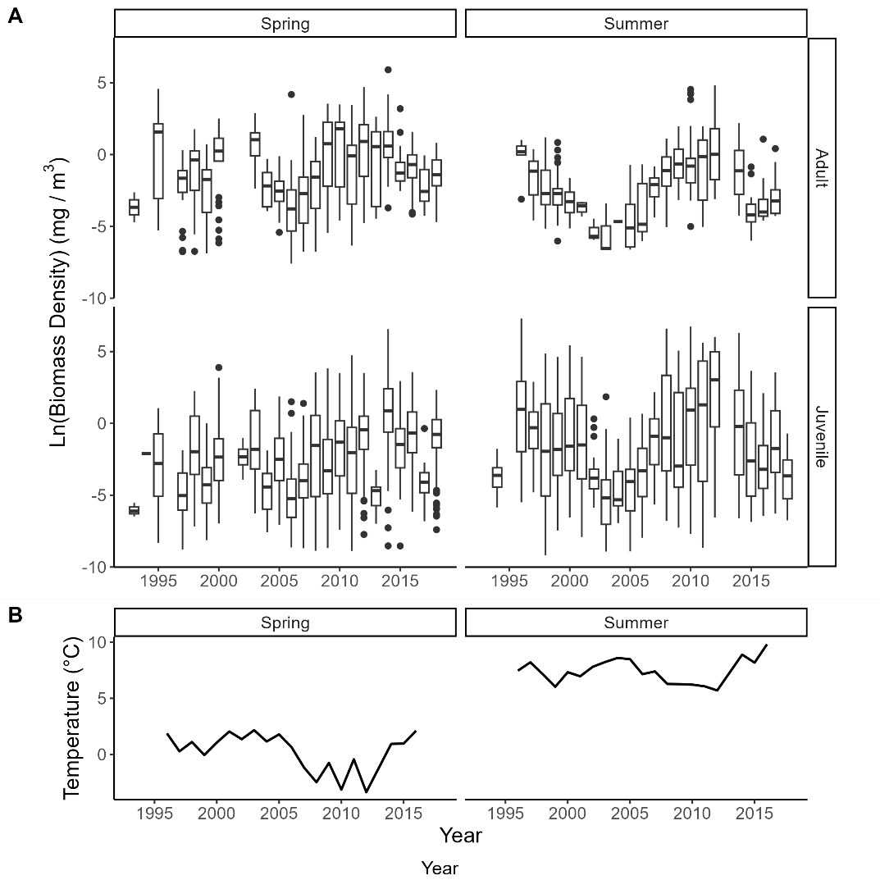

### Figure 3. Physiological rates at equilibrium on a per capita (A through D) and population (E through H) basis predicted in the model. For the ingestion plots (A, E), the dotted line represents the maximum ingestion rate, while the solid line represents the emergent ingestion rate at equilibrium.



### Figure 4. Equilibrium biomass densities as a function of temperature, for adults (left), juveniles (middle) and resources (right).

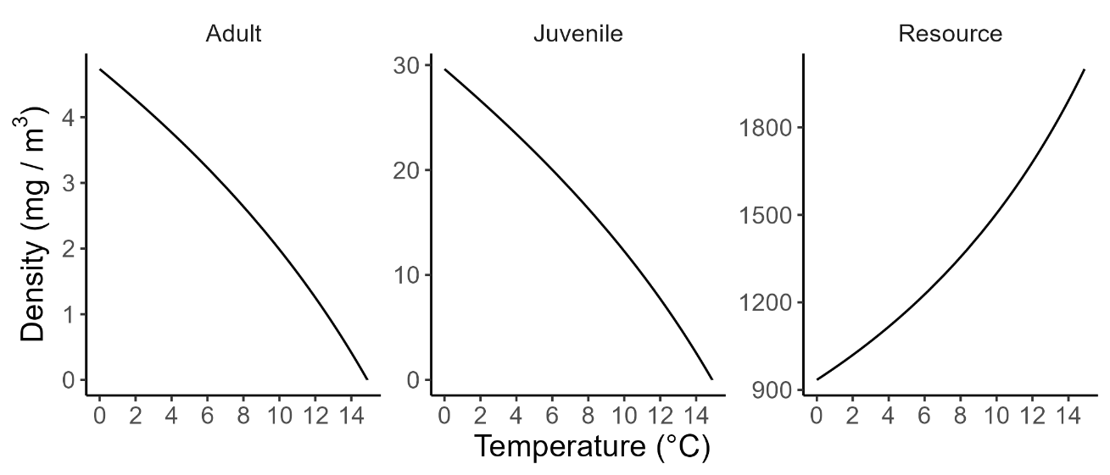

### Figure 5. Observed (red) and predicted (blue) *Calanus* biomass densities at observed mean summer sea surface temperatures from 1996 to 2017 (excluding 2013).

### Figure 6. Predicted per capita and population level birth rate and net production with changes in temperature.

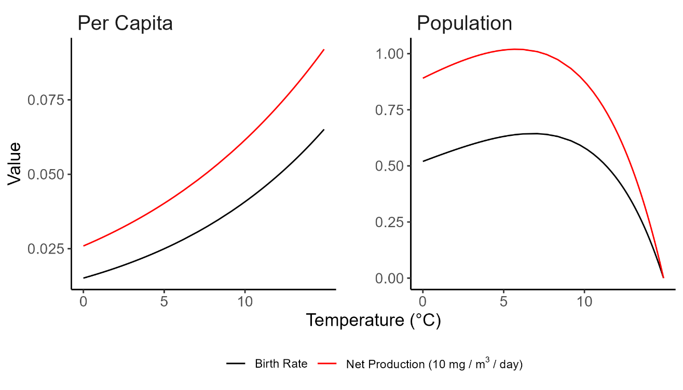

### Figure 7. Relationship between size at maturity and extinction temperature



### Figure 8. Change in stage-specific biomass density as a function of size at maturity at 14.8 °C (A) and the change in the adult to juvenile biomass density ratio with changes in size at maturity at this temperature (B).

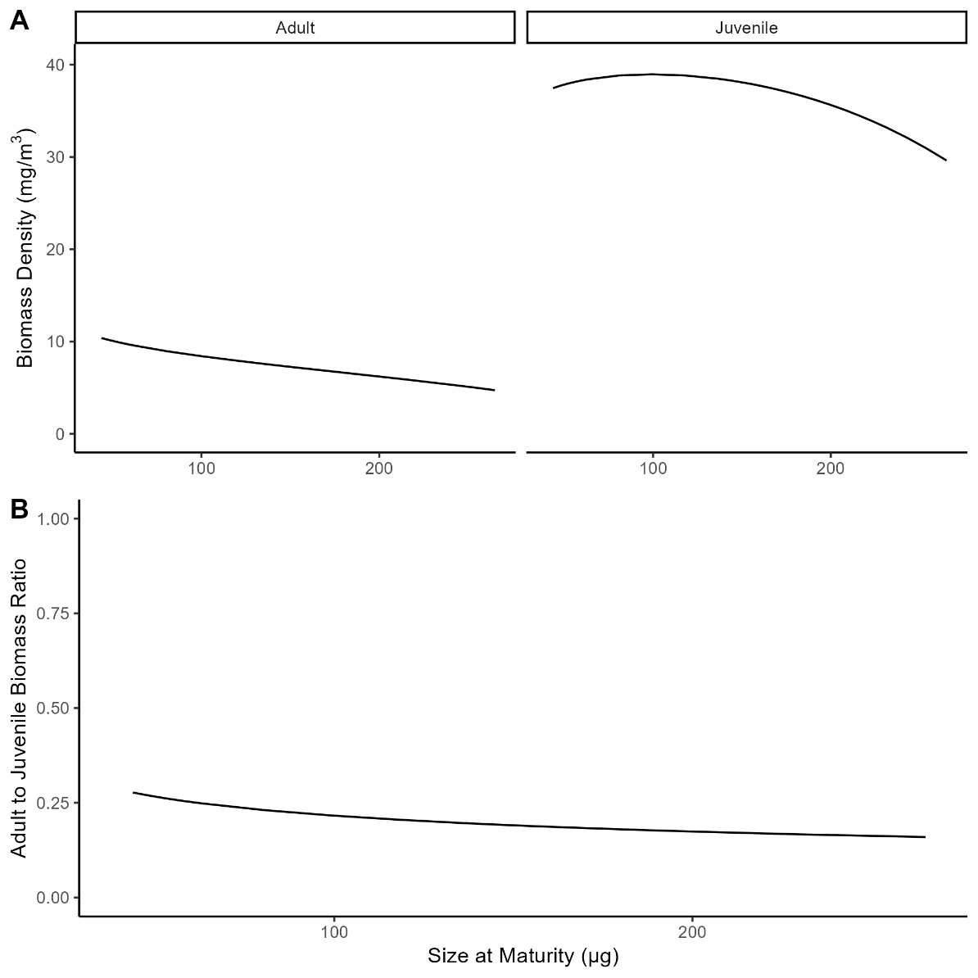

## LITERATURE CITED

Ainsworth, C.H., Samhouri, J.F., Busch, D.S., Cheung, W.W.L. Dunne, J., and T.A. Okey. 2011.

Potential impacts of climate change on Northeast Pacific marine foodwebs and fisheries.

ICES Journal of Marine Science, 68: 1217-1229.

Atkinson, D. 1994. Temperature and organism size - a biological law for ectotherms? Advances

in Ecological Research 25: 1-58.

Atkinson A, Rossberg AG, Gaedke U, Sprules G, Heneghan RF, Batziakas S, Grigoratou M,

Fileman E, Schmidt K, Frangoulis C (2024) Steeper size spectra with decreasing phytoplankton biomass indicate strong trophic amplification and future fish declines. Nat Commun 15:381.

Angilletta, M. J., Steury, T. D. & M.W. Sears. 2004. Temperature, growth rate, and body size in

ectotherms: fitting pieces of a life-history puzzle. Integrative and Comparative Biology.

44: 498-509.

\

Barton, S. and Yvon-Durocher, G. 2019, Quantifying the temperature dependence of growth rate

in marine phytoplankton within and across species. Limnology and Oceanography 64:

2081-2091.

Berrigan, D. & Charnov, E. 1994. Reaction norms for age and size at maturity in response to

temperature: a puzzle for life historians. *Oikos*, **70**, 474–478.

Brown, J. H., Gillooly, J. F., Allen, A. P., Savage, V. M. & G.B. West. 2004. Toward a

metabolic theory of ecology. Ecology 85: 1771-1789.

Buckley, T. W., Ortiz, I., Kotwicki, S. & K. Aydin. 2016. Summer diet composition of walleye

pollock and predator–prey relationships with copepods and euphausiids in the eastern

Bering Sea, 1987–2011. Deep Sea Research Part II: Topical Studies in Oceanography

134: 302-311.

Campbell, R.G. et al. 2016. Mesozooplankton grazing during spring sea-ice conditions in the

eastern Bering Sea. Deep-Sea Research Part II: Topical Studies in Oceanography 134:

157-172.

Choquet M, Kosobokova K, Kwasniewski S, Hatlebakk M, Dhanasiri A.K.S, Melle W, Daase M,

Svensen C, Soreide JE., and G. Hoarau. 2018. Can morphology reliably distinguish

between the copepods Calanus finmarchicus and C glacialis, or is DNA the only way?

Limnology and Oceanography-Methods 16:237-252

Daufresne, M., Lengfellner, K. & U. Sommer. 2009. Global warming benefits the small in

aquatic ecosystems. Proceedings of the National Academy of Science USA 106:12788-

12793.

de Roos, A.M., Schellekens, T. van Kooten, T., van de Wolfshaar, K., Claessen, D. and L.

Persson. 2007. Food‐dependent growth leads to overcompensation in stage‐specific

biomass when mortality increases: The influence of maturation versus reproduction

regulation. The American Naturalist, 170: E59-E76.

de Roos, A.M. et al. 2008. Simplifying a physiologically structured population model to a stage-

structured biomass model. Theoretical Population Biology 73: 47-62.

de Roos, A. M., Diekmann, O. & J.A.J., Metz. 1992. Studying the dynamics of structured

population models - a versatile technique and its application to *Daphnia*. American

Naturalist 139: 123-147.

de Roos, A.M., 2021. PSPManalysis. A package for numerical analysis of physiologically

structured population models. https://CRAN.R-project.org/package=PSPManalysis.

Dorn, M. et al. 2018. A climate science regional action plan for the Gulf of Alaska. US

Department of Commerce, National Oceanic and Atmospheric Administration.

Deutsch, C. Penn, J.L. W.C.E.P., Verbek, and J.L. Payne. 2022. Impact of warming on

aquatic body sizes explained by metabolic scaling from microbes to macrofauna.

Proceedings of the National Academy of Sciences 119: 1-9.

Forster, J., & Hirst, A. G. 2012. The temperature-size rule emerges from ontogenetic

differences between growth and development rates. Functional Ecology, 26(2), 483–492. https://doi.org/10.1111/j.1365-2435.2011.01958.x

Frost, B.W. 1972. Effects of size and concentration of food particles on the feeding behavior of

the marine planktonic copepod *Calanus pacificus*. Limnology and Oceanography 17:

805-815.

Frost, B.W. 1974. *Calanus marshallae*, a new species of calanoid copepod closely allied to

the sibling species *C. finmarchicus* and *C. glacialis*. Marine Biology 26: 77-99.

Garcia-Soto C., Cheng L., Caesar L., Schmidtko S., Jewett E.B., Cheripka A., Rigor I., Caballero

A., Chiba S, Báez J.C., Zielinski T. and J.P. Abraham. 2021. An overview of ocean

climate change indicators: Sea surface temperature, ocean heat content, ocean pH,

dissolved oxygen concentration, arctic sea ice extent, thickness and volume, sea level and

strength of the AMOC (Atlantic Meridional Overturning Circulation). Frontiers in Marine

Science 8:642372.

Gardner, J. L., Peters, A., Kearney, M. R., Joseph, L. & R. Heinsohn. 2011. Declining body size:

a third universal response to warming? Trends in Ecology & Evolution 26: 285-291.

Garzke, J., Ismar, S. M. H. & U. Sommer. 2015. Climate change affects low trophic level marine

consumers: warming decreases copepod size and abundance. Oecologia 177: 849-860.

Garzke, J., Hansen, T., Ismar, S. M. H. & U. Sommer. 2016. Combined Effects of Ocean

Warming and Acidification on Copepod Abundance, Body Size and Fatty Acid Content.

PLoS One 11.

Gillooly, J. F., Brown, J. H., West, G. B., Savage, V. M. & E.L. Charnov. 2001. Effects of size

and temperature on metabolic rate. Science 293: 2248-2251.

Gluchowska, M., Dalpadado, P., Beszczynska-Moller, A., Olszewska, A., Ingvaldsen, R.B., and

S. Kwasniewski. 2017. Interannual zooplankton variability in the main pathways of the

Atlantic water flow into the Arctic Ocean (Fram Strait and Barents Sea branches). ICES

Journal of Marine Science, 74: 1921–1936.

Grebmeier, J.M. 2012. Shifting patterns of life in the Pacific Arctic and sub-Arctic seas. Annual

Review of Marine Science 4: 63-78.

Heneghan R.F., Everett J.D., Blanchard J.L., Sykes P., and A.J. Richardson. 2023. Climate-driven

zooplankton shifts cause large-scale declines in food quality for fish. Nature Climate

Change.

Hermann AJ, Gibson GA, Cheng W, Ortiz I, Aydin K, Wang M, Hollowed AB, Holsman KK,

and S. Sathyendranath. 2019. Projected biophysical conditions of the Bering Sea to 2100

under multiple emission scenarios. ICES Journal of Marine Science 76:1280-1304.

Hjelm, J. & Persson, L. 2001. Size-dependent attack rate and handling capacity: inter-cohort

competition in a zooplanktivorous fish. *Oikos,* 95**,** 520-532.

Hunt, G. L., Jr. et al. 2011.Climate impacts on eastern Bering Sea foodwebs: a synthesis of new

data and an assessment of the Oscillating Control Hypothesis. ICES Journal of Marine

Science 68: 1230-1243.

Huntley, M.E. and M.D.G. Lopez. 1992, Temperature-Dependent Production of Marine

Copepods: A Global Synthesis. The American Naturalist 140: 201-242.

Holling, C. S. 1959. The components of predation as revealed by a study of small mammal

predation of the European pine sawfly. Canadian Entomology 91: 93–320.

Ianora, A. 1998. Copepod life history traits in subtemperate regions. Journal of Marine Systems,

15: 337-349.

Incze, L. S., Siefert, D. W. & J.M. Napp. 1997. Mesozooplankton of Shelikof Strait, Alaska:

Abundance and community composition. Continental Shelf Research 17: 287-305.

Ikeda, T., Sano, F., and Yamaguchi, A., 2007. Respiration in marine pelagic copepods: a global-

bathymetric model. Marine Ecology Progress Series 339: 215-219

Intergovernmental Panel on Climate Change (IPCC). 2021. Climate Change 2021: The Physical Science Basis. Contribution of Working Group I to the Sixth Assessment Report of the Intergovernmental Panel on Climate Change. Cambridge University Press.Kimmel, D. G. 2011. Trophic Relationships of Coastal and Estuarine Ecosystems. Treatise on

Estuarine and Coastal Science. eds Wilson J.G., & Luczkovich, J.J., Academic Press.

Kimmel D.G., and J.T. Duffy-Anderson. 2020. Zooplankton abundance trends and patterns in

Shelikof Strait, western Gulf of Alaska, USA, 1990–2017. Journal of Plankton Research

42:334-354.

Ladd, C., and P. J. Stabeno. 2012. Stratification on the Eastern Bering Sea shelf revisited. Deep

Sea Research Part II: Topical Studies in Oceanography 65–70:72–83.

Lefort, S., O. Aumont, L. Bopp, T. Arsouze, M. Gehlen, and O. Maury. 2015. Spatial and body-

size dependent response of marine pelagic communities to projected global climate change. Global Change Biology 21:154–164.

Lindmark, M., Huss, M., Ohlberger, J. & A. Gårdmark. 2018. Temperature-dependent body size

effects determine population responses to climate warming. Ecology Letters 21, 181-189.

Marshall S.M., Nicholls A.G., and A.P. Orr. 1935. On the biology of *Calanus finmarchicus*. Part

VI. Oxygen consumption in relation to environmental conditions. Journal of the Marine

Biological Association of the United Kingdom. 20: 1-27.

Martins, I.S. et al. 2023. Widespread shifts in body size within populations and assemblages.

Science, 381: 1067-1071.Maps, F., Pershing, A.J., and N.R. Record. 2012. A generalized approach for simulating growth

and development in diverse marine copepod species. ICES Journal of Marine Science 69:

370-379.

Maps, F., Record, N.R., and A. Pershing. 2014. A metabolic approach to dormancy in pelagic

copepods helps explaining inter- and intra-specific variability in life-history strategies.

Journal of Plankton Research 36: 18-30.

Marañón E, Cermeño P, Huete-Ortega M, López-Sandoval DC, Mouriño-Carballido B, et al.

2014. Resource Supply Overrides Temperature as a Controlling Factor of Marine

Phytoplankton Growth. PLOS ONE 9: e99312

McCoy, M.W., and J.F. Gillooly. 2008. Predicting natural mortality rates of plants and animals.

Ecology Letters 11: 710-716.

Megrey, B.A., Rose, K.A., Ito, S., Hay, D.E., Werner, F.E., Yamanaka, Y., and M.N. Aita. 2007.

North Pacific basin-scale differences in lower and higher trophic level marine ecosystem

responses to climate impacts using a nutrient-phytoplankton–zooplankton model coupled

to a fish bioenergetics model. Ecological Modelling, 202: 196-210.

Melillo, J. M., Richmond, T. C. & G.W. Yohe. 2014. Climate Change Impacts in the United

States: The Third National Climate Assessment.

Morán X. A.,  López-Urrutia Á., Calvo-Díaz A., and W.W. Li. 2009. Increasing importance of

small phytoplankton in a warmer ocean, *Global Change Biology*, 16:1137-1144.

Naganuma, T. 1996. Calanoid copepods: linking lower-higher trophic levels by linking lower-

higher Reynolds numbers. Marine Ecology Progress Series 136,: 311-313.

Napp, J. M., Incze, L. S., Ortner, P. B., Siefert, D. L. W. & L. Britt. 1996. The plankton of

Shelikof Strait, Alaska: Standing stock, production, mesoscale variability and their

relevance to larval fish survival. Fisheries Oceanography**5**: 19-38.

Nelson, R. J., Carmack, E. C., McLaughlin, F. A. & G.A. Cooper. 2009. Penetration of Pacific

zooplankton into the western Arctic Ocean tracked with molecular population genetics.

Marine Ecology Progress Series 381: 129-138.

Ohlberger, J. 2013. Climate warming and ectotherm body size – from individual physiology

to community ecology. Functional Ecology 27: 991-1001.

Parmesan, C. & G.A. Yohe. 2003 globally coherent fingerprint of climate change impacts across

natural systems. Nature 421: 37-42.

Persson, L., Leonardsson, K., de Roos, A.M., Gyllenberg, M., and B. Christensen. 1998.

Ontogenetic Scaling of Foraging Rates and the Dynamics of a Size-Structured Consumer-Resource Model. Theoretical Population Biology 54:270–293.

Peter, K. H. & U. Sommer. 2012. Phytoplankton Cell Size: Intra- and Interspecific Effects of

Warming and Grazing. PLoS One 7.

Peter, K. H. & U. Sommer. 2013. Phytoplankton Cell Size Reduction in Response to Warming

Mediated by Nutrient Limitation. PLoS One 8.

Peters, R. H. 1983. The ecological implications of body size. Cam- bridge University Press,

Cambridge.

Putland, J.N., and R.L. Iverson. 2007. Phytoplankton Biomass in a

Subtropical Estuary: Distribution, Size Composition, and Carbon:Chlorophyll Ratios.

Estuaries and Coasts 30: 878-885.

Rice, E., Dam, H. G. & G. Stewart. 2015. Impact of Climate Change on Estuarine Zooplankton:

Surface Water Warming in Long Island Sound Is Associated with Changes in Copepod

Size and Community Structure. Estuaries and Coasts 38: 13-23.

Saiz, E., and A. Calbet. 2007. Scaling of feeding in marine calanoid copepods. Limnology and

Oceanography 52: 487-921.

Sigler, M.F. et al. 2011. Fluxes, Fins, and Feathers Relationships Among the Bering, Chukchi,

and Beaufort Seas in a Time of Climate Change. Oceanography 24: 250-265.

Strasburger, W. W., Hillgruber, N., Pinchuk, A. I. & F.J., Mueter. 2014. Feeding ecology of age-

0 walleye pollock (*Gadus chalcogrammus*) and Pacific cod (*Gadus macrocephalus*) in

the southeastern Bering Sea. Deep Sea Research Part II: Topical Studies in

Oceanography 109: 172-180.

Strom, S. L., and K. A. Fredrickson. 2008. Intense stratification leads to phytoplankton nutrient

limitation and reduced microzooplankton grazing in the southeastern Bering Sea. Deep Sea Research Part II: Topical Studies in Oceanography 55(16):1761–1774.

Walther, G.R. et al. 2002 Ecological responses to recent climate change. Nature 416: 389-395.

Wang, M., Overland, J. E. & N.A. Bond. 2010. Climate projections for selected large marine

ecosystems. Journal of Marine Systems 79: 258-266.

White, E. P., Ernest, S. K. M., Kerkhoff, A. J. & B.J. Enquist. 2007. Relationships between body

size and abundance in ecology. TRENDS in Ecology and Evolution 22: 323-330.

Wilson, M. T., Buchheister, A. & C. Jump. 2011. Regional variation in the annual feeding cycle

of juvenile walleye pollock (*Theragra chalcogramma*) in the western Gulf of Alaska.

Fishery Bulletin 109: 316-326.

Woodworth-Jefcoats, P.A., Polovina, J.J., and J.C. Drazen. 2017. Climate change is projected to

reduce carrying capacity and redistribute species richness in North Pacific pelagic marine

ecosystems. Global Change Biology, 23: 1000–1008.

Yodzis, P., and S. Innes. 1992. Body size and consumer resource dynamics. American Naturalist

139:1151–1175. Yvon-Durocher, G. et al. 2015. Five years of experimental warming

increases the biodiversity and productivity of phytoplankton. Public Library of Science

Biology 13.

Yvon-Durocher, G., Montoya, J. M., Trimmer, M. & G. Woodward. 2011. Warming alters the

size spectrum and shifts the distribution of biomass in freshwater ecosystems. Global

Change Biology 17: 1681-1694.